**LWC JEST UNIT TEST CASE DEVELOPMENT**

Step 1: Need to install the npm command for sfdx-lwc-jest

npm install @salesforce/sfdx-lwc-jest --save-dev

Step 2: In LWC component create a folder with __test__ inside create a file

If your salesforce version is above 56 no need to create a separate folder in your LWC component once, you create LWC component it automatically gives you the test file as default. If your version is below 56 or 55 then we must create a test file manually.

Step 3: Now create a LWC compont go to Js file

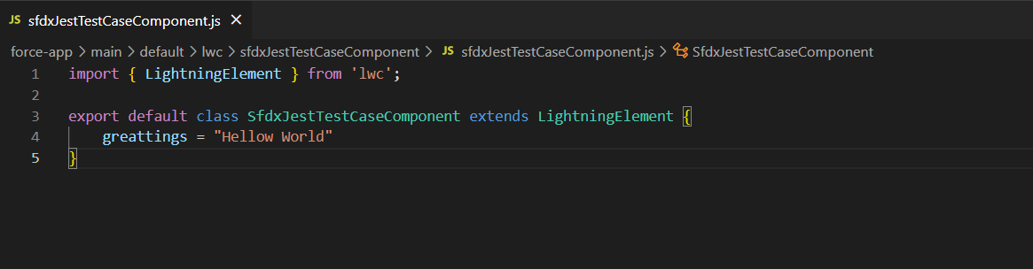

Now in sfdxJestTestCaseComponent.test.js we must describe that greeting in your test file

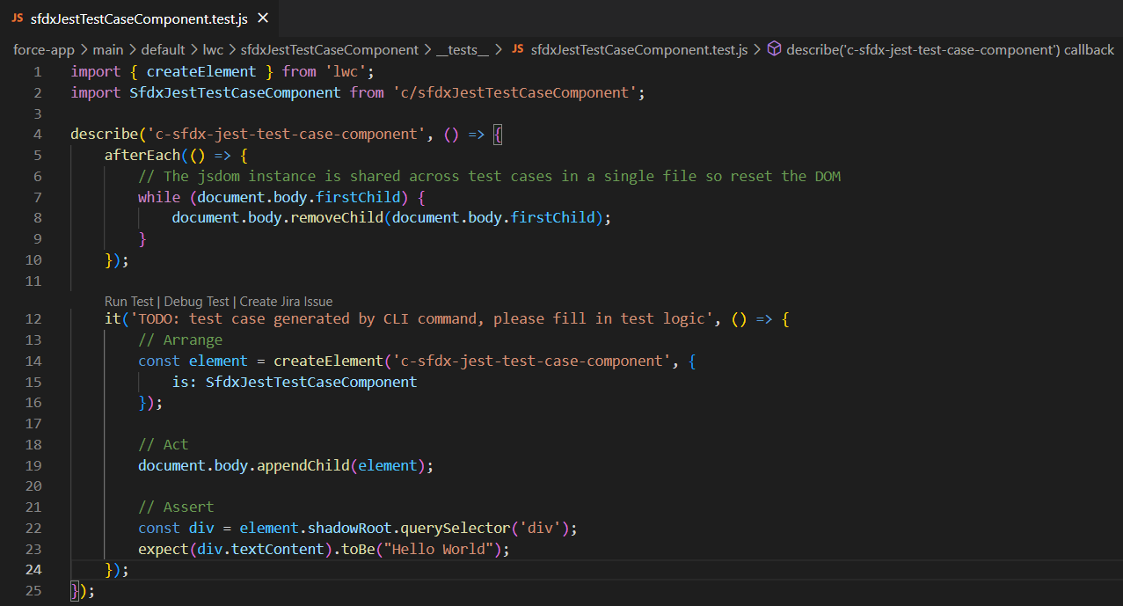

SO here I am testing for the simple text so I used as textContent similarly if you use methods, Strings, arrays there will differently options to check that conditions.

Please check this link as a reference

<https://jestjs.io/docs/expect>

Step 4: Now check your test case from the sfdxJestTestCaseComponent.test.js on top the page you will find the green button and click on that it will run your test case for current component.

